1. Define power law relationships between two variables.

A power law relationship between two variables takes the form of y~ax^{b}, and states that some variable y grows proportional to some variable x to some power of b (with coefficient a).

2. Explain how does the method of least squares work.

The method of least squares (or simple linear regression) for fitting a line to data is to minimize the sum of squared residuals.

This is done by taking the partial derivatives with respect to a and b and solving for a and b such that the two derivatives are equal to zero in order to find the extrema of the function. The a and b values corresponding to the minima are the values defining the line of best fit to the data.

3. How do we linearize exponential relationship between data?

Exponential linearization is done by taking the log of both sides and redefining the variables such that a linear function is obtained.

where;

4. How do we linearize power laws?

Power law linearization is done by taking the log of both sides and redefining the variables such that a linear function is obtained.

where;

5. Define and sketch the logistic curve. What is the meaning of parameters r and M?

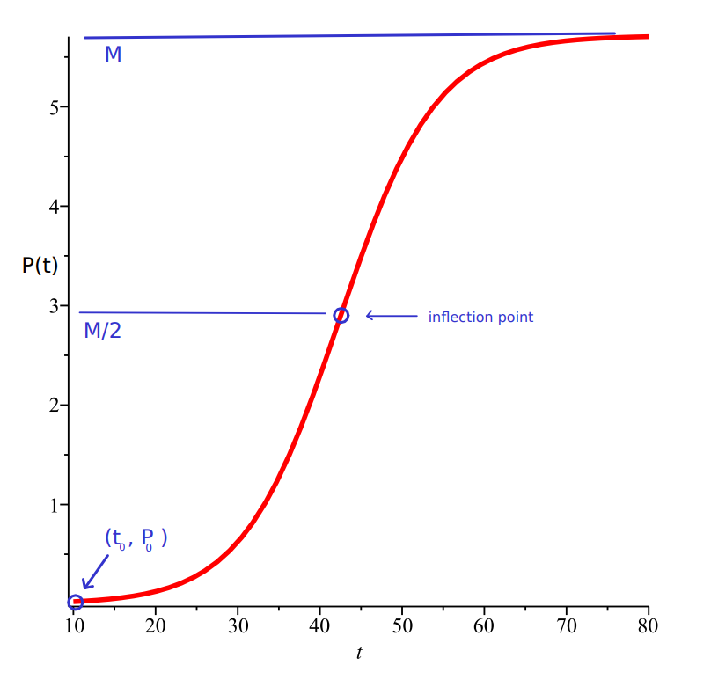

The parameter r defines the steepness of the curve, where the parameter M defines the upper asymptote and the inflection point

6. Describe the monofera model with unlimited growth.

The monofera model with unlimited growth is a model of the population of imaginary creatures called monofera. These creatures, each produce a single offspring at each time interval Δt with probability λΔt.

7. Demonstrate how the monofera model gives rise to exponential growth.

If at time t the population of monofera is N(t), then at time t+Δt, the expected value of the population is given by:

Taking the limit as Δt → 0:

If N(0) is assumed to be N₀ the following initial value problem is obtained:

With the solution:

8. What is power law exponential growth?

Power law exponential growth is a relationship between two variables: the rate of growth and some other independent variable. In the case of the monofera, this takes the form of:

9. Describe monofera growth model with harvesting

The monofera growth model with harvesting is a model of the population of monofera with the addition of a ‘harvesting rate’ or ‘death rate’. That is, at time interval Δt, hΔt monofera are removed from the population.

10. What is extinction time?

If N(t) defines the population at time t, extinction time is the time at which N(t) = 0.

11. Describe “monofera in space” model.

The monofera in space model is a model of the population of monofera which live in restricted space. That is, there is a finite amount of space in which the population can grow in. Each monofera attempts to produce an offspring at time interval Δt with probability λΔt in a randomly selected cell. If this cell is occupied, the newly produced monofera dies.

12. Show how to obtain the logistic differential equation from the above model.

Let the maximum population of monofera (the total number of sites) be M. Since each monofera produces offspring at time interval Δt with probability λΔt, each empty cell has the probability of being occupied from each of the monofera in the current population with probability

The probability of a cell not receiving new life from a given occupied cell is then given by:

and the probability of a cell not receiving new life from any occupied cell is given by:

The probability of receiving life from at least one occupied cell is then given by:

when is small.

The expected number of unoccupied cells which become occupied in time interval Δt is then:

and the expected number of occupied cells at time t is:

Taking the limit as Δt → 0, the logistic differential equation is obtained:

13. Define takeover time and show how it is used to transform the logistic curve to its universal form

Takeover time is the time required for a population density to go from 0.1 to 0.9.

Let where P(t) is the logistic curve;with parameters t₀, P₀, M, and r.

Then:

If t₁ is the time corresponding to U(t) = 0.1 and t₂ is the time corresponding to U(t) = 0.9, then takeover time T = t₂ – t₁ is the time required for the population density to increase from 0.1 to 0.9, and:

Takeover time is then expressed as:

And therefore:

If:

we obtain the universal curve:

14. List some examples of power laws occurring in nature

- population growth
- innovation substitution
- income distribution

15. What is Zipf law?

Zipf’s law states that the frequency of a word is inversely proportional to it’s rank. The rank of a word is given by it’s position in the list of all words, ordered by descending frequency.

16. What kind of power law is associate with a random walk?

In a random walk, the standard deviation from the starting position of the walker after time t is proportional to

17. Are there any power laws in epidemic processes?

If we let individuals on a lattice have the ability to spread infection by direct contact and become immune after recovery, the total number of recovered individuals grows as

18. How would you define cellular automata?

A cellular automaton is a discrete model consisting of an n-dimensional lattice with cells in one of m states. At any given timestep, the state of the cells are updated simultaneously and independent of any other cells defined by some fixed rule.

19. Define elementary cellular automaton.

An elementary cellular automaton is a 1-dimensional cellular automaton where each cell has two possible states and the rule for updating the cells is defined solely by a cells current state and it’s two immediate neighbors. The

20. How is Wolfram number computed?

The wolfram number is the number corresponding to the binary number obtained by ordering the rules in ascending order as if they were binary numbers.

For example, rule 30 is defined as:

{0, 0, 0} = 0
{0, 0, 1} = 1
{0, 1, 0} = 1
{0, 1, 1} = 1
{1, 0, 0} = 1
{1, 0, 1} = 0
{1, 1, 0} = 0
{1, 1, 1} = 0

This is verified by checking that the binary number 00011110 is in fact 30 as follows:

21. Let the local function of an elementary CA be defined as f(x1, x2, x3) = x1x2x3. Find its Wolfram number.

F(x₁,x₂,x₃) = 0 unless x1 = x₂ = x₃ = 1 → 10000000

2⁷ = 127

22. Define majority voting rule
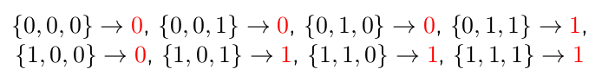
The majority voting rule, rule 232, is define as:

23. Which elementary rule can be interpreted as a simple model of road traffic? Define local function for this rule.

The elementary rule with wolfram number 184 can be interpretted as a simple model for road traffic. The local function for this rule is:

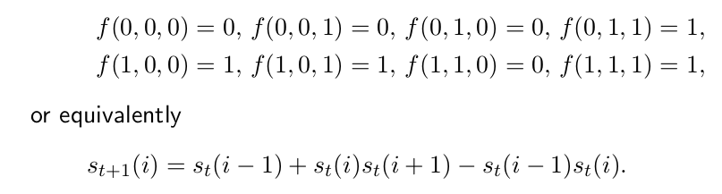

24. How do we construct initial configurations drawn from Bernoulli distribution?

An initial configuration is drawn from the Bernoulli distribution by defining a probability, p. Any given cell is then given a starting state of 1with probability p, and any given cell is in state 0 with probability 1 - p.

25. When is Bernoulli distribution called “symmetric”?

The Bernoulli distribution is called symmetric when p =

26. What are periodic boundary conditions and why do we use them in simulations of spatial systems (such as, for example, cellular automata)?

Periodic boundary conditions are a condition imposed for handling the boundaries of the lattice. In this case, on a lattice on size n with indices numbers 0 to n-1, the right neighbor of the cell n-1 is cell 0, and the left neighbor of cell 0 is cell n-1.

27. How do we implement periodic boundaries in C++ using “modulo” operator?

Periodic boundaries can be implemented in C++ on a lattice of size n by using the index of
(i+n-1) mod n for the left neighbor and (i+1) m,od n for the right neighbor, where i is the index of the cell to be updated.

28. Give some examples of power laws in cellular automata.
- Rule 18: The number of pairs of cells in state 11 decreases with time.as
- Rule 54: The number of “g_{e} particles” decreases over time as

29. What are the differences between rule 184 and the Nagel-Schreckenberg model?

The Nagel-Schreckenberg model added the following improvements to ECA 184:

- Acceleration – if not at max velocity, increase velocity by 1
- Slowing Down – if distance between car in front is less than current velocity, reduce velocity to number of empty cells in front.
- Randomization – The speed of all cars with velocity greater than 1 have their velocity reduced with some probability p.
- Car motion – Cars are moved forwards the number of cells equal to their velocity.

30. What do we mean by “fundamental diagram”?

The fundamental diagram is the tent shaped diagram produced from data obtained by the Nagel-Schreckenberg model, strongly resembling the diagram produced from real data on traffic flow.

31. Do you know any power laws associated with road traffic flow?

- distribution of duration of traffic jams

32. Why is the rule 184 considered a model of surface deposition process?

33. Describe random deposition (RD) model.

34. Describe ballistic deposition (BD) model.

35. Write the recursive equation which h(i, t) satisfies in BD model.

36. Define the mean height of the surface and the interface width.

37. Sketch the typical plot of w(L, t) as a function of t in BD model.

38. Explain the terms: crossover time, roughness exponent, growth exponent, dynamic exponent.

39. Show that in RD model, β = 1/2.

40. What are the values of α and z for RD model?

41. What are the values of α, β and z for the BD model?

42. What is “Family-Vicsek scaling relation”?

43. What do we mean by “scaling law”?

44. What is the difference between site percolation and bond percolation?

45. What do we mean by “cluster” in percolation models?

46. What do we mean by “critical probability”?

47. State the theorem pertained to the probability of existence of an infinite cluster.

48. What is the relationship between p bond c and p site c ?

49. Do we know the exact value of pc for bond percolation on the square lattice? What about site
percolation on the square lattice?

50. Does the infinite cluster exist when p = pc?

51. How is Bethe lattice constructed?

52. Compute the critical probability for site percolation on Bethe lattice.

